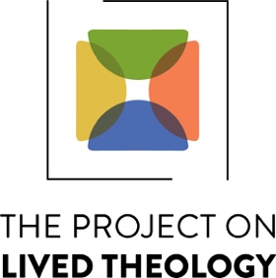

UNDERGRADUATE SUMMER RESEARCH FELLOWSHIP IN LIVED THEOLOGY
Application for Summer 2021

Deadline: April 1, 2021

The Project on Lived Theology is a research community housed in the Religious Studies Department at UVA that seeks to understand the social consequences of theological ideas.

The UNDERGRADUATE SUMMER RESEARCH FELLOWSHIP IN LIVED THEOLOGY offers undergraduates an opportunity to conduct research, think, and write theologically on questions related to the social repercussions of theological commitments. Past fellowship recipients have explored diverse themes, such as Religion and Civil Rights; Community Development and Organizing; Immigration Reform; Environmental Sustainability and Farming; and Religion, Mental Health, and the Arts.

The fellowship is open to UVA undergraduate students (or recent graduates) in any field of study. Each fellow will receive a $3,000 stipend.

In addition, each fellow is expected to work directly with a UVA faculty member, who will act as a theological-academic mentor and offer guidance in reading, research, and writing about selected texts.

Throughout the summer, fellows are expected to write blog posts for the Project on Lived Theology website about their research progress and discoveries. In the early fall, at an agreeable date, the summer fellows will present their work at a public event. PLT staff will assess the COVID-19 situation at that time to determine whether this event can be held in person on Grounds or should happen virtually.

We ask interested applicants to complete the following information:

Name:

Email Address:

Year of Graduation:

Major:

Proposed Mentor and Their Affiliation:

In 500 words (or less), please describe why you are interested in applying to the Fellowship in Lived Theology and what you hope to contribute to the Project on Lived Theology during your fellowship.

Email completed application and any questions to: livedtheology@virginia.edu

The Project on Lived Theology
Source Document

Lived theology begins with a modest proposal. How might theological writing, research, and teaching be expanded or reimagined so as to engage lived experience with maximum interpretive care and precision? How might the discipline of theology, in its method, style, and pedagogy, appear anew if narrated accounts of religious practices are appropriated as constitutive elements of theological knowledge? In this manner, lived theology foregrounds embodied particularity in theological narrative. Our hope is to conciliate diverse theological traditions around the patterns and practices of lived experience and in so doing inspire an ever-widening ecumenism that animates and is animated by faith’s redemptive practices. Lived theology seeks to bring to light all that we learn as scholars and practitioners when, as the late English Roman Catholic theologian Nicholas Lash wrote, “we attend, calmly and fearlessly, to the actual complexity, obscurity and intractability of our circumstances.”

